Historical Fiction

Are you interested in stories and events that took place in the past? Historical fiction is based on historical events or people. Although some facts may be true, most of the story is fictionalized. Starred (*) authors have other books in this genre. Check them out!
≈
Purple Hibiscus by Chimamanda Ngozi Adichie
FIC Adi
The limits of fifteen-year-old Kambili’s world are defined by the high walls of her family estate and the dictates of her fanatically religious father. When Nigeria is shaken by a military coup, Kambili’s father, involved mysteriously in the political crisis, sends her to live with her aunt.

In the Time of the Butterflies by Julia Alvarez*
FIC Alv
This book is inspired by the true story of the three Mirabal sisters who, in 1960, were murdered for their part in an underground plot to overthrow the government. Alvarez breathes life into these historical figures--known as "las mariposas," or "the butterflies.”

The Pox Party by M.T. Anderson*
FIC And
Various diaries, letters, and other manuscripts chronicle the experiences of Octavian, a young African American, from birth to age sixteen, as he is brought up as part of a science experiment in the years leading up to and during the Revolutionary War.

The Red Badge of Courage by Stephen Crane
FIC Cra
Bored with farm life, and anxious for some excitement, Henry Fleming sets off to join the Union troops fighting the Civil War. An inexperienced fighter, he is anxious to get into battle to prove his patriotism and courage.

Pope Joan by Donna Woolfork Cross
FIC Cro
When her older brother is killed, Joan, a rebellious ninth-century woman, assumes his identity, enters a monastery and becomes a great Christian scholar, eventually attaining the throne of Pope.

The Farming of Bones by Edwidge Danticat
FIC Dan
Trujillo's racist regime marked the end of peaceful coexistence between Haitians and Dominicans with the deplorable Massacre of 1937. This tragic and horrific ethnic cleansing is remembered by Amabelle, an aging Haitian woman who lived through this period as a young girl. Orphaned when her parents are swept away by a swollen river, she is cared for by the Haitian community across the river in the Dominican Republic.

Cold Mountain by Charles Frazier
FIC Fra
Inman is a disillusioned Confederate soldier who has failed to die as expected after being seriously wounded in battle during the last days of the Civil War. He decides to desert, and embarks on a dangerous and lonely journey, heading home to North Carolina and seeking only to be reunited with his beloved, Ada.

Waterboys by Eric Gabriel
FIC Gab
A Hell's Kitchen street kid and his two friends are forced to choose between the conflicting values of home and New York streets.

Monkey Hunting by Cristina Garcia*
FIC Gar
Chen Pan, having signed a contract in 1857 that takes him from China to Cuba where he is enslaved on a sugar plantation, manages to escape his bonds, find love, and create a life for himself and successive generations in the foreign land.

Map of Ireland by Stephanie Grant
FIC Gra
In 1974, the first year of busing in Boston, Massachusetts, seventeen-year-old Ann Ahern's lesbianism, which has isolated her from other white students, draws her to her African French teacher and leads her to insights into Blacks' struggles in the post-Civil Rights era.

The Other Boleyn Girl by Philippa Gregory*
FIC Gre
When Mary Boleyn comes to court as an innocent girl of fourteen, she catches the eye of Henry VIII. Dazzled by the king, Mary falls in love with both her golden prince and her growing role as unofficial queen. However, she soon realizes just how much she is a pawn in her family's ambitious plots as the king's interest begins to wane and she is forced to step aside for her best friend and rival: her sister, Anne.

Leonardo’s Shadow by Christopher Grey
FIC Gre
Fifteen-year-old Giacomo, servant to Leonardo da Vinci, helps his procrastinating master finish painting, "The Last Supper," while also trying to find clues to his parentage and pursue his own career as an artist in late fifteenth-century Milan.

Never Fall Down by Patricia McCormick
FIC McC
When soldiers arrive in his hometown in Cambodia, Arn Chorn Pond is separated from his family and sent to a labor camp, where he works in the rice paddies until he volunteers to learn to play an instrument--a decision that both saves his life and lands him in battle.

Brave Enemies by Robert Morgan
FIC Mor
When her husband is captured by the British, pregnant Josie Summers Trethman disguises herself as a man, joins the North Carolina militia, and finds herself trapped in the midst of Cowpens, the turning-point battle of the Revolutionary War.

Fallen Angels by Walter Dean Myers*
FIC Mye
Seventeen-year-old Richie Perry, just out of his Harlem high school, enlists in the Army in the summer of 1967 and spends a devastating year on active duty in Vietnam.

Shanghai Girls by Lisa See*
FIC See
Forced to leave Shanghai when their father sells them to California suitors, sisters May and Pearl struggle to adapt to life in 1930s Los Angeles while still bound to old customs, as they face discrimination and confront a life-altering secret.

Between Shades of Gray by Ruta Sepetys
FIC Sep
In 1941, fifteen-year-old Lina, her mother, and brother are pulled from their Lithuanian home by Soviet guards and sent to Siberia, where her father is sentenced to death in a prison camp. Lina fights for her life, vowing to honor her family and the thousands like hers.

Daughter of War by Marsha Forchuk Skrypuch
FIC Skr
Marta, a young Armenian refugee, survives the Armenian genocide in Turkey during World War I, and disguises herself as a Muslim in order to locate her betrothed and her sister, who were sold into slavery.

Buffalo Soldiers by Tom Willard
FIC Wil
From the Civil War to Desert Storm, there stretches an unbroken line of dedicated, distinguished service by African-Americans in the US military. Buffalo Soldiers is a tribute to the bravery, honor, and sacrifice of these black American fighting men.

The Book Thief by Mark Zusak
FIC Zus
Trying to make sense of the horrors of World War II, Death relates the story of Liesel--a young German girl whose book-stealing and story-telling talents help sustain her family and the Jewish man they are hiding, as well as their neighbors.

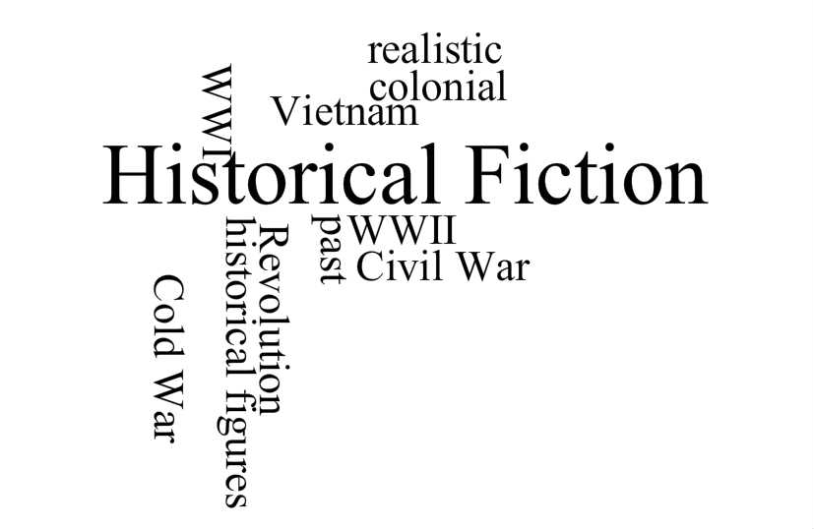 Find it
@
BHS Library

BHSlibrary.weebly.com

