Thrillers

.

“…what gives the variety of thrillers a common ground is the intensity of emotions they create, particularly those of apprehension and exhilaration, of excitement and breathlessness, all designed to generate that all-important thrill. By definition, if a thriller doesn't thrill, it's not doing its job.”
--James Patterson, June 2006, Thriller

The Winter Queen by Boris Akunin
In the 1870's a famous detective investigates the suicide of a wealthy student. He discovers evidence of a conspiracy of abductions, villains, beautiful women, and espionage, with deadly implications. (FIC Aku)

Angels and Demons by Dan Brown
A scientist is found brutally murdered, a professor must identify a mysterious symbol on his chest. Each revelation leads to a new danger. (FIC Bro)
Also by Dan Brown: The Da Vinci Code

Being by Kevin Brooks
After finding out he is part machine, sixteen-year-old Robert Smith runs from the covert government agents who are trying to pin a murder on him, and together with Eddi, a nineteen-year-old criminal, tries to uncover his true identity. (FIC Bro)

The Manchurian Candidate by Richard Condon
During the Cold War, the son of a prominent US political family is brainwashed into becoming an unwitting assassin for the Communist Party. (FIC Con)

Phoning a Dead Man by Gillian Cross
When John, a British demolitions expert, is supposedly killed blowing up a building in Siberia, his fiancée Annie insists on investigating, despite being in a wheelchair, and John's teenage sister Hayley goes along and finds that the Russian Mafia is involved. (FIC Cro)

Runner by Carl Deuker
Living with his alcoholic father on a broken-down sailboat on Puget Sound has been hard on seventeen-year-old Chance Taylor, but when his love of running leads to a high-paying job, he quickly learns that the money is not worth the risk. (FIC Deu)

Little Brother by Cory Doctorow
After being interrogated for days by the Department of Homeland Security in the aftermath of a major terrorist attack on San Francisco, California, seventeen-year-old Marcus, released into what is now a police state, decides to use his expertise in computer hacking to set things right. (FIC Doc)

Eye of the Needle by Ken Follett
One enemy spy knows the secret to the Allies' greatest deception, a brilliant aristocrat and ruthless assassin -- code name: "The Needle" -- who holds the key to ultimate Nazi victory. Only one person stands in his way: a lonely Englishwoman on an isolated island, who is beginning to love the killer who has mysteriously entered her life. (FIC Fol)

The Human Factor by Graham Greene
Maurice Castle, a bureaucrat in the British intelligence service, pays a debt with the ultimate betrayal of his country. (FIC Gre)

The Pelican Brief by John Grisham
A bright young law student and an investigative reporter go underground while trying to expose a cover-up about the killings of two Supreme Court Justices. (FIC Gri)
Also by John Grisham: The Chamber, The Firm, The Rainmaker, A Time To Kill

A River Out of Eden by John Hockenberry
Francine Smoholla finds herself torn between her loyalties to her Native American tribe and her job responsibilities when dams that supply Washington's hydroelectric power threaten her tribe's native land. (FIC Hoc)

Stormbreaker by Anthony Horowitz
After the death of the uncle who had been his guardian, fourteen-year-old Alex Rider is coerced to continue his uncle's dangerous work for Britain's intelligence agency, MI6. (FIC Hor) Also in this series:
Ark Angel, Eagle Strike, Evil Star, Point Blank, Raven’s Gate, Scorpion, Skeleton Key

Evil Genius by Catherine Jinks
Child prodigy Cadel Piggot, an antisocial computer hacker, discovers his true identity when he enrolls as a first-year student at an advanced crime academy. (FIC Jin)

The Spy Who Came In From The Cold by John Le Carre
Veteran spy Alec Leamas, hoping to "come in from the cold" to retirement, is given one last bone-chilling assignment in which he is required to pretend defection and provide the enemy with sufficient evidence to label their leader a double agent. (FIC LeC)
Also by John LeCarre: Tinker Tailor Soldier Spy, The Bourne Identity, The Bourne Supremacy.

The Bourne Identity by Robert Ludlum
A man is picked up by a fishing boat, bullet-riddled and without memory, then races to elude assassins and recover from amnesia. (FIC Lud)
Also in this series: The Bourne Supremacy, Matarese Circle

The Door of No Return by Sarah Mussi
Sixteen-year-old Zac never believed his grandfather's tales about their enslaved ancestors being descended from an African king, but when his grandfather is murdered and the villains come after Zac, he sets out for Ghana to find King Baktu's long-lost treasure before the murderers do. (FIC Mus)

The Ruby in the Smoke by Phillip Pullman
In nineteenth-century London, sixteen-year-old Sally, a recent orphan, becomes involved in a deadly search for a mysterious ruby. (FIC Pul) Also in this series: Shadow in the North, The Tiger in the Well

The World Made Straight by Ron Rash
Travis is seventeen the summer he wanders into a marijuana grove and falls into a trap. He learns about the vicious farmer who set the trap and the evils hidden in the community. (FIC Ras)

Bad Monkeys by Matt Ruff
Jane Charlotte, arrested for murder, is referred to a psychiatrist who tries to figure out what is really going on after Jane explains that as a member of a secret group devoted to fighting evil, she is responsible for getting rid of irredeemable persons--otherwise known as "Bad Monkeys." (FIC Ruf)

Finding Lubchenko by Michael Simmons
Evan's father is framed for murder and bioterrorism, so high-school junior Evan, using clues from a stolen laptop, travels from Seattle to Paris with two friends to find the real culprit. (FIC Sim)

Gorky Park by Martin Cruz Smith
Chief Homicide Investigator Arkady Renko's investigation of three mutilated bodies reaches to the highest levels of the Communist hierarchy. (FIC Smi)
Also in this series: Polar Star, Stalin’s Ghost

Acceleration by Graham McNamee
Stuck working in the Lost and Found of the Toronto Transit Authority for the summer, seventeen-year-old Duncan finds the diary of a serial killer and sets out to stop him. (FIC McN)

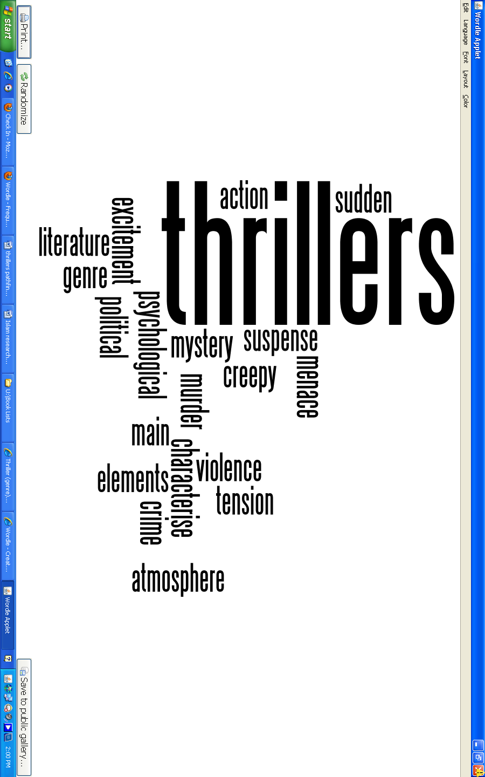

Find it
@
BHS Library

